An Application of 24GHz RADAR as a means of Contactless Heart Rate Monitoring: Interim Report

Written By: Oisín Watkins; 15156176

FYP Supervisor: Colin Fitzpatrick

ADI Supervisor: Padraic O’Reilly

# 1: Introduction and Project Outline:

This project title was first specified in consultation with and partly funded by the Automated Transport and Safety (ATS) department of Analog Devices, Inc. (ADI) Limerick. The goal come the end of the project is to demonstrate a system which is capable of measuring the heart rate of passengers in a car (one or multiple). This system would find its place in intelligent vehicles, more specifically in the automated emergency services contact system of intelligent vehicles. At present certain vehicles are fitted with systems which contact the emergency services in the event of a collision, however if more sophisticated passenger monitoring systems were incorporated it would be feasible to send a more detailed report to the emergency services, informing them as to what equipment they will require on site. Furthermore, these systems can retain information from the cockpit of the car from before an incident. This information would then be compiled into a report detailing the condition of the driver/passengers leading up to an incident.

To aid this project ADI Limerick have provided an ADI Demorad 24GHz Radio Detection and Ranging (RADAR) platform, as well as a selection of their Intellectual Property (IP) which pertains to this research. The largest majority of the development for this project took place in their European Research and Development Centre, while a large amount of the testing and optimisation took place on the campus of the University of Limerick. The IP provided by *ADI* was presented in both the Python 3.6 and MATLAB R2017b scripting languages. In both cases a style of Object-Oriented coding was employed, however during the initial setup of the project the MATLAB scripts ran far smoother and with fewer bugs, hence this was the platform chosen for the remainder of the project. Additionally, MATLAB provides an intuitive GUI builder, a tool which became very useful at later stages of the project such as testing and optimising.

Sections 3 and 4 of this report will be a quick look at the device being used, a detailing of the code being used as well as explanations behind the mathematics found therein and a brief look at the GUI designed so far. Sections 5 through 7 provide details of what is hoped for in the coming tests and a simple plan for the remainder of the FYP timeline.

# 2: Literature Survey:

The use of RADAR to measure heart and respiratory rates date back to the 1970’s [1][2], which used commercially available waveguide X-band Doppler transceivers. In recent years more research has been conducted to experiment with creating enclosed RADAR systems specifically with the goal of accurate heart-rate measurement, the most recent of which was in 2013 [3, 4]. These experiments achieved error rates of 1.7% and less given optimum range and angle to target for heart rate measurements. Other experiments were also conducted, and these will be listed in the references section of the report, however a popular design choice in these systems is the use of Doppler RADAR. This is a configuration whereby range to a target is ascertained by transmitting a Continuous Wave (i.e. the frequency does not change during transmission) and monitoring the phase angle difference between the transmitted and received signal. This methodology does offer exceptionally high resolution to range measurements, however the it presents challenges when it comes to measuring heart rates from multiple patients simultaneously. Høst-Madsen has shown that mathematically it is possible to meaure heart rate from multiple subjects using this technique, and has simulations to demonstrate this in the cited paper, however no actual tests were conducted. [3]

The use of Continuous Wave RADAR was not possible for this project, due to the limited IP provided. However, the antenna on the *Demorad* support Digital Beam Forming (DBF) quite well, which to date has not been applied to this application. DBF is an application of Frequency-Modulated Continuous Wave (FMCW) RADAR, which provides a range profile of the area in the device’s field of view. Objects in the field of view are detected by monitoring the beat frequency (a.k.a. the baseband frequency) on all 4 receive channels. A high-level description of the code which achieved this is provided later in the paper, however in this field one generally states that the *Demorad* utilises a “Multiple Input, Multiple Output” (MIMO) arrangement. Similar methodology has been used within ADI Limerick to develop a program which can track the movement of objects within the field of view of this device. Based on the theory, provided in section 3, this project aims to extend that functionality to also read the heartrate of the object moving through the field of view, assuming the object has physiological processes.

In recent years others have investigated the potential of MIMO Doppler RADAR setups to measure cardiopulmonary movement, as well as the effectiveness of FMCW RADAR for the same purpose [5, 6]. This project will investigate the prospect of using MIMO FMCW RADAR to achieve cardiopulmonary movement measurement. Achieving this will require a detailed understanding of the chest wall movement, as detailed in section 3.

# 3: Theory:

While it is fair to state that there are several contributing factors to the movement of a human’s chest wall, the two of interest for this particular project are the effects of respiratory action (breathing) and cardiopulmonary movement (heartbeat). Much is known in this regard, here will be a brief outlining of the relevant details as well as how these will affect the measurement-taking method used in this application.

Viewing the biological process of interest in the frequency domain will provide the most benefit, for reasons explained later in this section. Respiratory motion typically remains in the 0.1-0.8Hz range, with exceptions occurring when a person is under physical stress or subject to certain physiological conditions. Likewise, the cardiopulmonary movement typically remains within the 0.8-2Hz range, subject to external/individual conditions. The measured respiratory movement will be a far stronger signal than that of the heartbeat, however it is difficult to characterise and therefore to measure. This is mainly due to there being multiple frequencies present in a single breath, all remaining within that 0.1-0.8Hz band. As respiration is of little interest in this project it is mostly removed by a type of band-pass filtering.

The remaining signal contains information about the heartbeat of the patient. Heartbeat is described as a nearly periodic signal, in that the period of each heartbeat can vary from on beat to the next. This is termed “Heartrate variability” (HRV). HRV can be modelled as a random process with strong periodicity [7]. While this characteristic of heartrate makes it somewhat easier to measure (via the application of band-pass filtering), one must keep in mind that the relative weakness of the signal can introduce considerable error in the measurement.

Bearing this in mind, multiple possible solutions exist to the same design problem. The solution which was chosen as the focus for this project is as follows: Use the RADAR platform to ascertain the range to the patient’s chest wall. Monitor this movement over time and perform a Fast Fourier Transform (FFT) on this recorded movement. Band-pass the resulting power spectrum into the bands listed above and find the corresponding peaks in each band. The peak will correspond to the frequency of movement which is most highly present in each band; respiration and heartrate respectively. To counteract the likely measurement error a type of filter may be applied to the heartrate measurements. The next step is to inspect the equipment at hand and begin working towards this solution.

# 4: Outline Design:

4.1: The ADI Demorad:

At the offset of this project there was no one device/platform available to the ATS group which completely met the requirements of the task. To prevent any interruption to progress ADI Limerick provided a set of evaluation boards for the ADF4159, ADF5901 and ADF5904, a PLL, Transmitter and Receiver/Mixer chip respectively. During the first months the LabVIEW automation language was employed, testing various configurations of each device listed as well as for the ADAR7251 ADC provided on the Evaluation board, and making the first steps in developing software for the task at hand. However eventually custom firmware for the microprocessor being used (the ADSP-BF700 “Blackfin”) was required, a task which according to experts is enough to dedicate a whole FYP to. At this point the supervisors on site at ADI worked to find a replacement setup for the evaluation kits.

During the first stages of the project, before the firmware issue was encountered, another group within the ATS department, the Applications group, had worked to get access to the new RADAR platforms being designed by ADI. The Demorad platform was one of the platforms ADI was given access to. The primary components of the platform were the very chips which comprised the evaluation setups the project began with, so the initial work done was translated from LabVIEW to MATLAB R2017b, the reasons for which are explained in the introduction. As of that point, which was late November 2017, a second Demorad platform was commissioned to this project as the first platform was damaged beyond repair. Figure 1 illustrates the platform, in the references section will be links to the datasheets for each of the primary chips mentioned in this section [8-12]

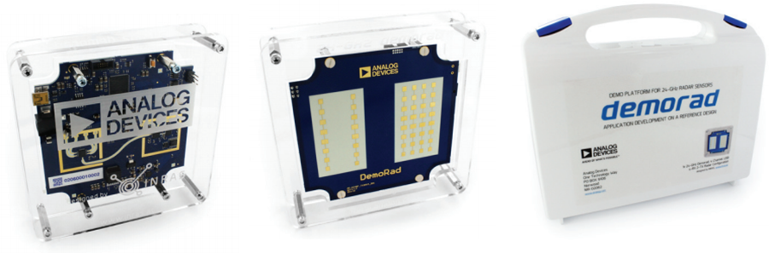

Figure 1: An image of the ADI Demorad 24GHz RADAR platform [13]

4.2: The Algorithm:

This section will discuss (sometimes in brief and sometimes in detail) the various elements that make up the program which has been designed to run on the *Demorad*. Certain steps cannot be detailed due to copyrighting of ADI IP; however, every operation of major interest will be detailed in as much as can be done.

Much of the initial code used cannot be shared as it details certain classes needed to make the code functional and other copyrighted code belonging to *ADI*, however what follows in this section will be a high-level overview of the algorithm designed for this project.

Figure 2 shows a simple chain of events which occurs at the beginning of the script. Once the connection to the board is established, the FMCW frequency ramp is initialised, space is stored in the computer’s memory for the measurement info to follow, the maximum duration of the test is saved into memory and the measurement then begins.

Figure 2: Initial steps to Heart Rate measurement

The following while loop contains nearly all of the main functionality of this script. One iteration of the while loop corresponds to one measurement of heart rate. Note however that one measurement of heart rate requires a predefined number of data collections from the board. This number of measurements impacts the resolution of the measurement. As part of the FFT function in MATLAB the sampling rate of the range measurement is required. This is initialised in the first step of the loop. Once a stream of the beat signal, who’s length is defined previously as 256 samples long, is captured the waveform is filtered using the “smoothdata” command. To take full advantage of the MIMO functionality the beat signal data must first be organised into information received from Tx1 and Tx2. This organised information can be used to create a range profile of the space in front of the device.

Once the range profile is created and the data is stored into the variable “JNorm” a differencing algorithm is run on it. This effectively copies the data into a new variable, “Frame_Odd” or “Frame_Even”, and subtracts the frame captured on the previous run of the for loop from the newest frame. In doing so any static object will be ignored and only moving targets will be tracked.

Once complete, this differenced range profile then has a threshold applied to remove some low-level noise. Finally, the software focuses on the peak value found in that profile. This is taken to be the patient. Once found the software will make note of the current range to the target. On the next run of the for loop another measurement will be taken, and so on and so forth. This range information is then saved into a buffer for DSP provided later on.

A Fast Fourier Transform (FFT) is then performed on the differenced range profile. The FFT data is searched for the respiratory and cardiopulmonary information. Note the respiration data is only a rough estimate as it is not the focus of this project. The only difference with the heart rate measurement is that a moving average filter is applied to the measurements to account for HRV. This is in fact how many optical heart rate trackers operate, such as the Sp02 device which will be used as a reference in the testing procedure. When testing commences multiple versions of averaging filters will be tested, the one which produces the most accurate results will be the one implemented in the final version of the software. The remainder of the code is simply controlling the timing of the program, printing the results of the above code to the GUI and saving the information into an Excel sheet. A simplified visualisation of this loop is given in Figure 3.

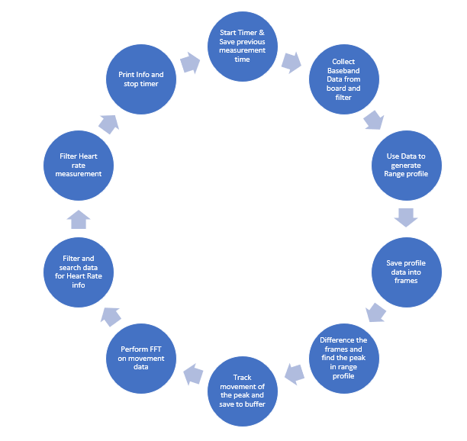

Figure 3: Chain of events inside the main While loop of the code

4.3: The Graphical User Interface:

Figure 4 is a screenshot of the Graphical User Interface developed in MATLAB R2017B’s graphical user interface development environment (guide). In the lower right corner is the differenced range profile generated using code listed above. In the upper right corner is the plot of the FFT performed on the movement data gathered over time. In the upper left corner is the control panel, where the user inputs the number of measurements required (if known), the resolution of the FFT desired (which impacts both the accuracy of the measurement and the time taken for a single measurement), the maximum duration for the entire test in minutes and a checkbox which will allow the algorithm to run continuously for a maximum time entered in the maximum duration variable. Also, in the control panel is the output terminals for both the respiration and heartrate measurements.

4

# 5: Action Plan:

Here will be a list of all objectives already achieved and a list of deliverables which are left to be achieved in the remainder of the FYP timeline. These will be listed separately due to how far along the project currently is. Dates provided will be rough estimates of when the objectives were reached or will be reached, given that certain objectives were attained in parts over the course of days, weeks or months.

5.1: Objectives Reached:

1. Successfully communicate with the Demorad platform (November 2017 – January 2018)
2. Compile Bibliography and read relevant papers in research area (February – September 2018)
3. Develop code to take a ranged profile of the Demorad’s field of view (June – September 2018)
4. Investigate methods to take heartrate measurements based both on the physiological motion of the chest wall and on the means by which the previous objective has been reached (September 2018)
5. Iteratively improve the measurement method, basing improvements on the results from non-conclusive testing while bearing in mind the limitations of computing power and testing environment (September – October 2018)
6. Propose experiment to be conducted in the Anechoic chamber on UL campus to finalise improvements to the software (October 2018)

5.2: Objectives to Reach:

1. Test software in Anechoic chamber while making improvements to software based on the results. This will be an iterative process conducted over the course of weeks (Pending approval)
2. Verify results and compile data (December 2018 – January 2019)
3. Finalise the design and prepare for presentation (January – February 2019)
4. Present findings and design (March – April 2019)

5.3: Gannt Chart

The Gannt chart shown in figure 5 summarises the tasks and groups some together according to similarity. This also only considers the time frame from May 2018 until March 2019 as this is when the largest amount of time was/will be dedicated to this project.

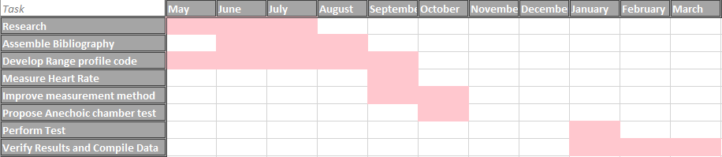

Figure 5: Gannt Chart

# 6: Requirements:

Given all that has been achieved to date and the list of objectives yet to be achieved the only remaining requirement from the university is the approval of the experiment in the Anechoic chamber. For completeness below is the experiment proposal as submitted to the FYP supervisor:

***Name:*** Oisín Watkins

***Student ID:*** 15156176

***Date:*** 08/10/2018

***Proposal Title:*** Heart Rate Measurements in the Anechoic Chamber.

Herein is listed the goals, parameters, settings and risks for an FYP experiment proposal in the Anechoic Chamber located in the main building, C-block, floor 0 of UL Campus. This missive is sent with the purpose of requesting permission to use the anechoic chamber for the experiment outlined below.

Within this document reference is made to “The Subject”, meaning the volunteer who agreed to take part in this experiment. Bob Strunz has agreed to step in as the subject for this experiment. Given his experience using the chamber this also removes the need for a third supervisor to be present.

**Goals:**

The FYP title I am working towards is: “An Application of 24GHz RADAR as a means of Contactless Heart Rate Monitoring”. Both the RADAR platform being used for this project as well as the software/firmware required to accomplish this task have been provided by Analog Devices Inc. Limerick. A working prototype is now fully engineered and ready to be tested. To provide ideal-scenario measurements an anechoic chamber is required. The goal of this experiment is to acquire data from live Human volunteers (both using my non-contact RADAR measurements and using an SpO2 fingertip measurement as a reference) from within a noiseless environment.

**Parameters:**

This experiment will measure only two metrics: The Heart Rate of the subject using the RADAR method, and the Heart Rate of the subject using the SpO2 fingertip sensor. No other devices will be necessary. The RADAR will be positioned 1m away from the subject at chest height with the antenna parallel to the subject’s chest wall. The fingertip sensor will be attached to the subject’s right index finger. Both devices will be connected to a laptop being operated immediately outside the chamber.

**Settings:**

The RADAR will be positioned as specified in the Parameters section. The subject will be seated on a plastic chair placed in the middle of the catwalk in the chamber. The subject will be facing in the direction of the door, with the RADAR between the subject and the door.

**Risks:**

Medical risks are at a minimum for this experiment. The maximum power level permitted for unlicensed 24GHz microwave transmission is 1mW (0 dBm), though most domestic appliances are well below this level. When last checked on site in Analog Devices Inc. the Demorad’s power output averaged at -10dBm (though no image of this was saved. This is worth measuring on campus if possible to confirm).

There is also the possibility of damage to the foam lining of the chamber itself. Supervision from an experienced user of the chamber will be necessary to minimise this risk.

***Conclusion:***

Given the above experiment description I would like to request permission to use the anechoic chamber to run 10 experiments on the subject, who has been briefed on the nature of the experiment, each experiment lasting a maximum of 10 minutes. The most efficient organisation of the total 100 minutes would be to spread them out over the course of 3 weeks at most.

# 7: Conclusion:

Aside from this experiment nothing else is required from the university itself. All remaining goals will require working closely with the FYP supervisor, however this will largely include analysing data and present results. No monetary costs on behalf of the university will be required. For the consideration of the Electronic and Computer Engineering department of the University of Limerick this report details the premise for this research and a detailed explanation of the experiment planned to bring the research into its final phase.

# References:

[1] J. C. Lin, J. Kiernicki, M. Kiernicki, P. B. J. I. T. o. M. T. Wollschlaeger, and Techniques, "Microwave apexcardiography," vol. 27, no. 6, pp. 618-620, 1979.

[2] J. C. J. P. o. t. I. Lin, "Noninvasive microwave measurement of respiration," vol. 63, no. 10, pp. 1530-1530, 1975.

[3] A. Høst-Madsen, N. Petrochilos, O. Boric-Lubecke, V. M. Lubecke, B.-K. Park, and Q. Zhou, "Signal processing methods for Doppler radar heart rate monitoring," in *Signal Processing Techniques for Knowledge Extraction and Information Fusion*: Springer, 2008, pp. 121-140.

[4] W. Ser, J. Yu, X. Guo, J. Zhang, and M. E. H. Ong, "Noncontact heart rate measurement using a 24 GHz Doppler radar," in *Microwave Workshop Series on RF and Wireless Technologies for Biomedical and Healthcare Applications (IMWS-BIO), 2013 IEEE MTT-S International*, 2013, pp. 1-3: IEEE.

[5] O. Boric-Lubecke, V. M. Lubecke, A. Host-Madsen, D. Samardzija, and K. Cheung, "Doppler radar sensing of multiple subjects in single and multiple antenna systems," in *Telecommunications in Modern Satellite, Cable and Broadcasting Services, 2005. 7th International Conference on*, 2005, vol. 1, pp. 7-11: IEEE.

[6] L. Anitori, A. de Jong, and F. Nennie, "FMCW radar for life-sign detection," in *IEEE radar conference*, 2009, pp. 1-6.

[7] P. E. McSharry, G. D. Clifford, L. Tarassenko, and L. A. J. I. t. o. b. e. Smith, "A dynamical model for generating synthetic electrocardiogram signals," vol. 50, no. 3, pp. 289-294, 2003.

[8] D. S. ADF, "Direct Modulation/Fast Waveform Generating, 13 GHz, Fractional-N Frequency Synthesizer."

[9] D. S. ADF, "24 GHz VCO and PGA with 2-Channel PA Output."

[10] D. S. ADF, "4-Channel, 16-Bit, Continuous Time Data Acquisition ADC."

[11] D. S. ADF, "4-Channel, 24 GHz, Receiver Downconverter."

[12] D. S. ADF, "Blackfin+ Core Embedded Processor."

[13] G. Images, "<https://www.google.ie/search?q=inras+demorad&rlz=1C1CHBF_enIE755IE755&source=lnms&tbm=isch&sa=X&ved=0ahUKEwit8Zn6hZDeAhVkJMAKHSxVBJQQ_AUIDigB&biw=1920&bih=1089#imgrc=AwOthdQyjYj2PM>:," 10/09/2018.